Design Thinking Project Workbook

- Team

Team Name: Loan Eligibility Prediction

Team Members:
2320030089:- ABHIGNA-8897027438
2320030304:- SANTHOSHINI-9959688361
2320030218:- MAHALAKSHMI-9490298948
1.
- Problem/Opportunity Domain

Domain of Interest:
Financial Risk Assessment

Description of the Domain: A brief overview of the key elements, challenges, and opportunities within the domain.

Loan eligibility prediction assesses an applicant's financial status to determine creditworthiness. Key elements include income analysis, credit history, risk assessment models, and regulatory compliance. Challenges involve data accuracy, bias in AI models, and privacy concerns. Opportunities include faster loan processing, improved risk prediction, and enhanced financial inclusion. AI-driven solutions can streamline decision-making while ensuring fairness and efficiency.

Why did you choose this domain?: The personal or strategic reasons for selecting this domain, such as passion, market potential, or solving a specific problem.

This domain was chosen due to its strategic importance in financial decision-making and the growing need for automated, fair, and efficient loan approvals. The potential to reduce bias, enhance risk assessment, and streamline loan processing makes it a valuable area for innovation. Additionally, with the rise of AI and machine learning in fintech, this domain offers significant market potential. Personally, the challenge of improving financial accessibility while ensuring data-driven fairness is both intriguing and impactful.

- Problem/Opportunity Statement

Problem Statement:

Traditional loan approval processes are often slow, biased, and reliant on manual assessments, leading to inefficiencies and unfair outcomes. Financial institutions struggle with accurately assessing credit risk, resulting in high default rates or denial of credit to

deserving applicants. Additionally, existing systems may lack transparency and compliance with regulatory standards. This project aims to develop an AI-driven loan eligibility prediction system that enhances accuracy, reduces bias, and accelerates loan processing while ensuring fairness and compliance.

Problem Description:

Loan eligibility assessment is a critical process for financial institutions, determining whether an applicant qualifies for credit based on factors like income, credit score, and employment status. Traditional methods rely heavily on manual evaluation, which can be time- consuming, inconsistent, and prone to human bias. Inaccurate assessments may lead to loan defaults, financial losses, or the rejection of creditworthy applicants, limiting financial inclusion.

With the increasing adoption of AI and machine learning, there is an opportunity to develop a data-driven, automated loan eligibility prediction system. Such a system can improve accuracy, fairness, and efficiency, ensuring that lending decisions are made objectively while complying with regulatory requirements. Overcoming challenges like data quality, bias in models, and transparency in decision-making is essential to building a reliable and ethical solution.

Context (When does the problem occur):

The problem occurs during the loan application and approval process, where financial
institutions assess an applicant’s eligibility based on factors such as income, credit history, and employment status. It arises when applicants submit loan requests, and manual or outdated evaluation methods lead to delays, inconsistencies, and potential biases. Financial institutions often struggle with accurate risk assessment, which can result in either approving high-risk applicants or rejecting creditworthy ones. Additionally, regulatory compliance challenges arise when fairness and transparency in loan approvals are not ensured, leading to potential legal and ethical concerns. This issue is particularly significant in banks, fintech companies, and lending institutions, where efficient, data-driven decision-making is essential for financial stability and customer trust.

Alternatives (What does the customer do to fix the problem):

To address the challenges in loan eligibility assessment, financial institutions use various alternatives. Some rely on manual evaluation, where loan officers assess applications based on financial documents and interviews, but this process is slow and prone to human bias.
Others use traditional credit scoring models like FICO or CIBIL, which provide a
standardized score but may not fully capture an applicant’s financial behavior, especially for

those with limited credit history. Some institutions implement rule-based automated systems, which approve or reject applications based on predefined criteria, though they lack flexibility in handling unique cases. Additionally, lenders may turn to third-party credit risk assessments, outsourcing the evaluation to external agencies, but this increases costs and reliance on third-party data. A few fintech companies explore alternative data sources, such as utility payments and social behavior, to improve risk assessment, though privacy and regulatory concerns remain challenges. While these alternatives help mitigate some issues, they fail to fully eliminate bias, inefficiencies, or inaccuracies, highlighting the need for a more advanced, AI-driven loan eligibility prediction system.

Customers (Who has the problem most often): The primary group of individuals or organizations affected by the problem.
The primary groups affected by loan eligibility assessment challenges include financial institutions, lenders, and loan applicants. Banks, credit unions, and fintech companies struggle with accurately assessing credit risk while ensuring fair, fast, and compliant loan approvals. Loan applicants, especially those with limited credit history, freelancers, and small business owners, face difficulties in securing loans due to rigid or biased evaluation criteria. Additionally, government agencies and regulatory bodies overseeing financial fairness are impacted when lending institutions fail to comply with transparency and anti- discrimination regulations. The problem is most prevalent in high-volume lending environments, where delays, inaccuracies, or unfair denials can significantly impact financial stability and customer trust.
Emotional Impact (How does the customer feel):
Loan applicants often feel frustrated and anxious when facing delays or unfair rejections, especially if they lack a strong credit history. Financial institutions experience stress and pressure to balance risk management with customer satisfaction while ensuring regulatory compliance. Unfair lending practices can lead to distrust and disappointment, making customers feel excluded from financial opportunities. A lack of transparency in decisions causes uncertainty and dissatisfaction, affecting both borrowers and lenders.

Quantifiable Impact (What is the measurable impact):

Implementing an AI-driven loan eligibility system can reduce loan processing time from days to minutes, improving efficiency and customer experience. Advanced risk assessment models enhance approval accuracy by 20-30%, lowering default rates by 15-25% and ensuring better financial stability for lenders. By incorporating alternative data, financial institutions can expand credit access by 10-25%, especially for underserved populations. Additionally, automation can lead to 30-50% cost savings, minimizing reliance on manual reviews and third-party assessments.

Alternative Shortcomings (What are the disadvantages of the alternatives):
Manual evaluation is time-consuming and prone to human bias, leading to inconsistent loan approvals. Traditional credit scoring models fail to assess applicants with limited credit history, excluding many potential borrowers. Rule-based and third-party assessments lack flexibility, increase costs, and may still result in unfair lending decisions.

Link to showcase the problem:
https://www.worldbank.org/en/topic/financialinclusion https://www.mckinsey.com/industries/financial-services/our-insights

- Addressing SDGs

Relevant Sustainable Development Goals (SDGs): Identify which of the 17 SDGs are directly impacted by the problem or opportunity.

Loan eligibility prediction supports SDG 1 (No Poverty) and SDG 8 (Decent Work and Economic Growth) by improving credit access for individuals and businesses. It also aligns with SDG 9 (Industry, Innovation, and Infrastructure) and SDG 10 (Reduced Inequalities) by promoting AI-driven financial inclusion and fair lending practices.

How does your problem/opportunity address these SDGs?: Describe how solving the problem or leveraging the opportunity will contribute to achieving one or more SDGs.

Solving the loan eligibility prediction problem enhances financial inclusion by ensuring fair and efficient access to credit, directly contributing to SDG 1 (No Poverty) and SDG 10 (Reduced Inequalities). By automating and improving risk assessment, it fosters economic growth and entrepreneurship, aligning with SDG 8 (Decent Work and Economic Growth). Additionally, leveraging AI-driven solutions in lending enhances financial infrastructure and innovation, supporting SDG 9 (Industry, Innovation, and Infrastructure). This approach ensures equitable, transparent, and data-driven lending, reducing bias and increasing opportunities for underserved communities.

- Stakeholders
Answer these below questions to understand the stakeholder related to your project
  - Who are the key stakeholders involved in or affected by this project?
    - Consumers
    - • Loan Applicants –
    - • Financial Institutions & Lenders.
    - • Regulatory Bodies & Government Agencies.
    - • Data Scientists & AI Developers.
    - • Credit Scoring Agencies
    - • Consumer Advocacy Groups
    - • Investors & Stakeholders in Financial Markets

  - What roles do the stakeholders play in the success of the innovation?

    - Loan Applicants – Provide financial and personal data for evaluation; their feedback helps improve the fairness and accuracy of the system.

    - Financial Institutions & Lenders – Implement the AI-driven system, ensure proper integration with existing processes, and use insights to make lending decisions.

    - Regulatory Bodies & Government Agencies – Establish and enforce policies to ensure transparency, fairness, and compliance in AI-driven lending.

      - Data Scientists & AI Developers – Design, train, and refine machine learning models to enhance accuracy, reduce bias, and ensure ethical decision-making.
      - Credit Scoring Agencies – Supply reliable credit data, which plays a key role in evaluating borrower risk and improving prediction models.
      - Consumer Advocacy Groups – Monitor the system for potential biases, ensure fairness, and advocate for responsible AI use in lending.
      - Investors & Financial Market Stakeholders – Provide funding for AI-driven innovations and assess the impact of improved credit assessment on market stability.

  - What are the main interests and concerns of each stakeholder?

    - Loan Applicants – Want fair, fast approvals (Interest); worry about AI bias and privacy (Concern).

    - Financial Institutions – Seek accurate risk assessment (Interest); fear compliance and integration issues (Concern).

      - Regulatory Bodies – Aim for fair lending (Interest); concerned about AI bias and ethics (Concern).

    - Data Scientists – Focus on AI accuracy (Interest); face challenges with fairness and transparency (Concern).

  - How much influence does each stakeholder have on the outcome of the project?

    - Financial Institutions & Lenders – High Influence

      - They decide whether to adopt and implement the system, affecting its success.

    - Regulatory Bodies & Government Agencies – High Influence

      - Compliance laws and regulations can determine how AI-based lending systems operate.

    - Data Scientists & AI Developers – High Influence

    - Their expertise ensures the accuracy, fairness, and effectiveness of the AI model.

- Loan Applicants – Moderate Influence

  - Their demand and feedback shape system improvements and adoption.

- Credit Scoring Agencies – Moderate Influence

  - They provide essential data, but AI advancements may reduce their control over eligibility decisions.

  - What is the level of engagement or support expected from each stakeholder?

    - Financial Institutions & Lenders – High Engagement

      - Need to adopt, integrate, and refine the system for effective loan processing.

    - Regulatory Bodies & Government Agencies – High Engagement

      - Must ensure compliance, ethical AI use, and transparency in lending practices.

    - Data Scientists & AI Developers – High Engagement

      - Responsible for designing, training, and maintaining the AI model.

    - Loan Applicants – Moderate Engagement

      - Provide data, use the system, and offer feedback for improvements.

  - Are there any conflicts of interest between stakeholders? If so, how can they be addressed?
Conflicts arise between stakeholders in loan eligibility prediction. Applicants and lenders
differ on easy approvals vs. risk minimization, addressed through balanced AI models. Regulators and lenders may clash over transparency vs. profitability, solved with explainable AI. AI developers and credit agencies face competition, but collaboration on AI-driven insights can help. Consumer advocates and AI teams debate bias vs. efficiency, mitigated by audits and diverse data. Investors and regulators prioritize ROI vs. compliance, requiring ethical AI investment strategies.

  - How will you communicate and collaborate with stakeholders throughout the project?

Effective communication with stakeholders will be ensured through regular meetings, reports, and dashboards for financial institutions, while compliance reports and audits will keep regulatory bodies informed. Agile development cycles and model evaluations will guide AI developers, and user feedback surveys and support channels will engage loan applicants. Collaboration with credit scoring agencies will involve data-sharing agreements, while consumer advocacy groups will be involved through public reports and discussions on AI fairness. Finally, investors will receive financial reports and performance analytics to maintain confidence in the system.

  - What potential risks do stakeholders bring to the project, and how can these be mitigated?
Stakeholders bring risks such as AI bias (regulators, consumers), data privacy issues (applicants, credit agencies), and financial losses (investors, lenders). These can be mitigated through bias audits, strong data security measures, regulatory compliance, and transparent AI models.

- Power Interest Matrix of Stakeholders

Power Interest Matrix: Provide a diagrammatic representation of Power Interest Matrix
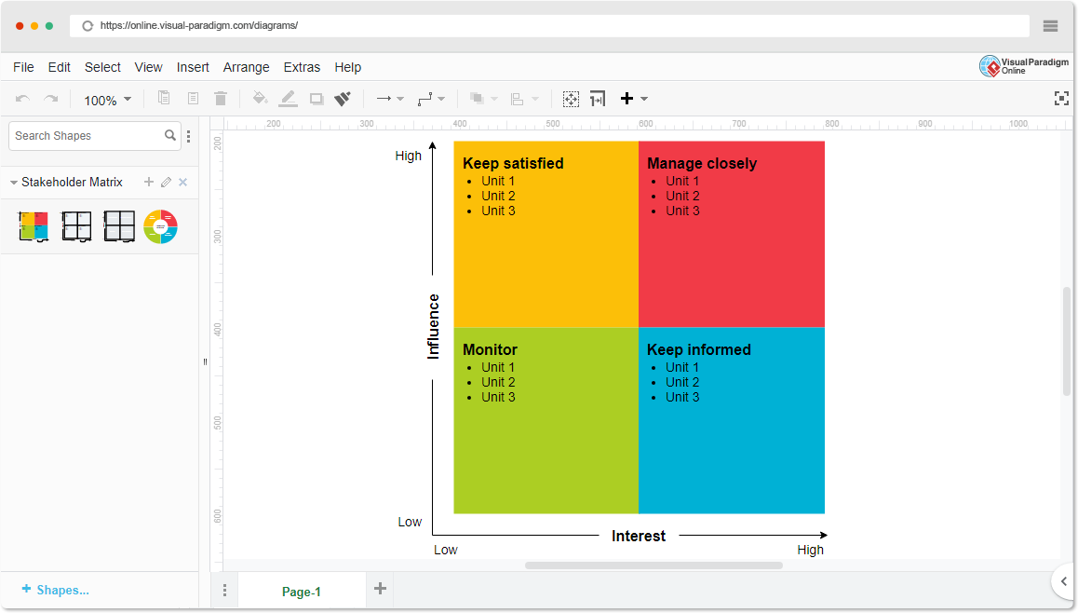

- High Power, High Interest (Manage Closely)
  - ◻ Financial Institutions & Lenders

  - ◻ Regulatory Bodies & Government Agencies

- High Power, Low Interest (Keep Satisfied)
  - ◻ Credit Scoring Agencies
  - ◻ Investors & Market Stakeholders

- Low Power, High Interest (Keep Informed)

  - ◻ Data Scientists & AI Developers
  - ◻ Consumer Advocacy Groups
  - Empathetic Interviews

Conduct Skilled interview with at least 30 citizens/Users by asking open ended questions (What, why/How etc) and list the insights as per the format below

I need to know (thoughts,  feelings, actions) | Questions I will ask (open questions) | Insights I hope to gain
Thoughts | How do you currently assess loan eligibility? | . How do you currently assess loan eligibility?
 | What are the biggest challenges in loan eligibility prediction? | Identify key pain points like bias, accuracy, and processing delays.
 | How do you ensure fairness and transparency in lending decisions? | . Gain insights into regulatory compliance and ethical AI concerns.
Feelings | What data points are most crucial for loan approval? | - Learn about key factors influencing eligibility, such as credit scores and income.
 | How do applicants feel about the loan approval process? | Understand customer frustrations, expectations, and trust levels.
 | What improvements would you like to see in loan prediction models? | Gather feedback on AI adoption, risk reduction, and user experience.

actions | How do you handle false positives and false negatives in loan approvals? | Gain insights into risk management and the impact of incorrect predictions.
 | What role does AI or automation currently play in your loan approval process? | Understand the level of technology adoption and potential for AI integration.
 | How do you ensure data privacy and security in loan processing? | Identify concerns around customer data protection and compliance with regulations.

SKILLED INTERVIEW REPORT
(Examples are given. Erase them and fill with your user information.)

User/Interviewee |  | Questions Asked | Insights Gained
Loan Officer | How do you currently assess loan eligibility? |  |  | Understanding of existing manual/automated processes.
Financial Institution Rep. |  | What are the biggest challenges in loan predictions? |  |  |  | Key pain points like bias, delays, and risk factors.
Regulatory Official | How do you ensure fairness in lending decisions? |  |  |  | Compliance measures and ethical concerns in AI lending.
Data Scientist | What data points are most crucial for loan approval? |  |  |  | Importance of credit score, income, and alternative data.
Loan Applicant | How do you feel about the loan approval process? |  |  |  | Applicant trust levels, frustrations, and expectations.

Key Insights Gained:

- oan Eligibility Assessment – Many institutions still rely on traditional credit scores, but there is growing interest in AI-driven models for faster and fairer assessments.

- Challenges in Loan Prediction – Major issues include bias in AI models, lack of transparency, and the difficulty of assessing applicants with little or no credit history.

- Fairness and Transparency – Regulators emphasize the need for explainable AI (XAI) to ensure fairness, while financial institutions seek a balance between compliance and profitability.

Empathy Map

- 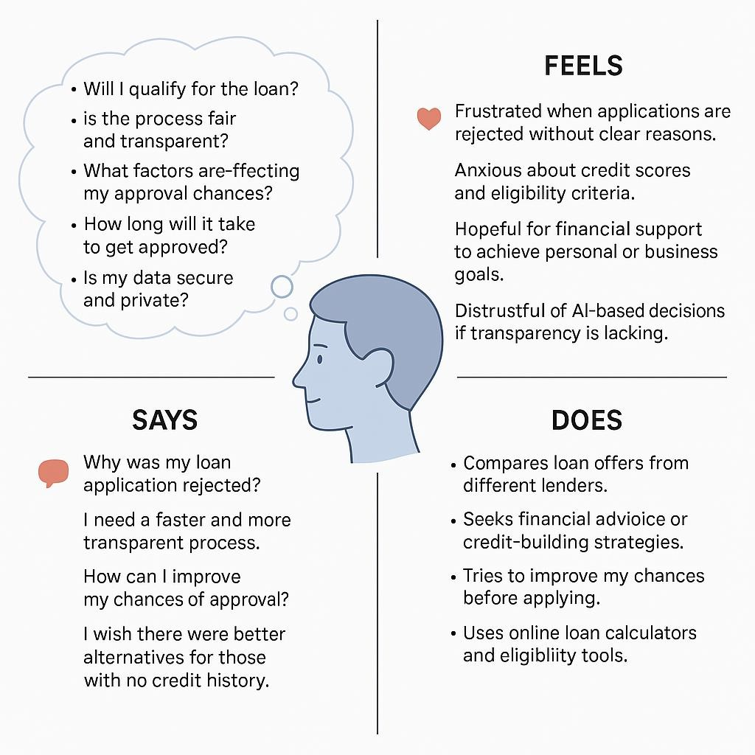
Who is your Customer?
Description: This is where you specify the customer or user you are empathizing with. It could be a specific user persona or a general user segment.

The primary customers are loan applicants, financial institutions, regulatory bodies, credit scoring agencies, and fintech companies seeking efficient and fair loan eligibility assessment.

- Who are we empathizing with?
Description: This area helps you define who the user is, what their situation looks like, and what role they play. It emphasizes understanding the user’s perspective in depth.

We are empathizing with loan applicants—individuals and businesses seeking financial assistance. They may face uncertainty, frustration, and anxiety due to complex eligibility

criteria, long approval times, and lack of transparency. Their role is to apply for loans to meet personal or business financial needs, often relying on credit scores and financial history, which may not always reflect their true ability to repay. Understanding their struggles helps create a fairer, faster, and more transparent loan approval system.

- What do they need to DO?
Description: This section identifies what actions or tasks the user needs to perform. It helps highlight the expectations and demands the user faces

Loan applicants need to research loan options, gather required financial documents, submit applications, and wait for approval decisions. They must also maintain a good credit score, provide accurate financial details, and sometimes justify their ability to repay the loan. If rejected, they may need to seek alternative financing options or improve their financial standing before reapplying.

- What do they SEE?
Description: This focuses on the visual stimuli or environment that the user interacts with. It's important to consider what users see in their immediate surroundings and in their larger world.

Loan applicants see online loan application portals, banking websites, and financial advertisements promoting different loan options. They may also encounter credit score reports, loan comparison charts, approval/rejection notifications, and customer reviews about lenders. In their larger world, they observe stories of people securing or struggling with loans, news about interest rates and financial regulations, and social media discussions on lending fairness and accessibility.

- What do they SAY?
Description: This section captures what the user might say in public, such as comments or feedback they give in conversations or on social media.

Loan applicants often express frustration over the lack of transparency in loan approvals, questioning why their applications were rejected without clear explanations. They frequently complain about long processing times and wish for faster, fairer alternatives. Many express concerns about being judged solely on their credit scores, believing that other financial factors should be considered. On social media and in conversations, they seek better loan options, lower interest rates, and clearer eligibility criteria, emphasizing the need for a more accessible and transparent lending system.

- What do they DO?
Description: This section focuses on what the user does, the actual behaviors they exhibit, and actions they take in different situations.

Loan applicants research loan options, compare lenders, and submit applications with required financial documents. If approved, they review loan terms and manage repayments; if

rejected, they seek alternatives or work on improving their creditworthiness. They may also consult financial advisors and engage in discussions about lending experiences.

- What do they HEAR?
Description: This addresses what information the user receives from external sources, such as colleagues, media, or industry trends. It helps map the influences surrounding the user.
Loan applicants hear about loan options, interest rates, and approval criteria from banks, financial advisors, and online lenders. They receive recommendations and warnings from friends, family, and online reviews about different lending experiences. The media and financial news inform them about economic trends, credit score importance, and new loan policies. Social media and forums amplify discussions on loan fairness, hidden fees, and better borrowing strategies.

- What do they THINK and FEEL?
Description: This is one of the most insightful sections, addressing the internal emotions, concerns, and motivations of the user. It helps identify their deep-rooted feelings.

Loan applicants often feel anxious and uncertain about their eligibility, fearing rejection due to credit scores or financial history. They worry about high interest rates, hidden fees, and long approval times, which can add stress to their financial situation. At the same time, they hope for a fair chance to secure a loan, whether for personal needs, education, or business growth. Their thoughts revolve around financial stability, repayment ability, and finding the best possible loan option, making transparency and trust in lenders crucial to their decision-making.

- Pains and Gains
Description: This section focuses on the user’s frustrations and their desired outcomes. It helps to frame the user’s challenges (pains) and the benefits they seek (gains).

Loan applicants often struggle with unclear rejection reasons, long processing times, and strict eligibility criteria that rely heavily on credit scores. High interest rates and hidden fees add to their financial burden, making repayment challenging. Many face limited access to loans, especially first-time borrowers or those with low credit history. They seek faster and more transparent approvals, fairer assessments that consider alternative financial data, and better loan terms with lower interest rates. Ultimately, they desire easier access to credit and improved financial security, ensuring loans genuinely support their financial growth.

8. Persona of Stakeholders Stakeholder Name:
Demographics: Key characteristics of your target audience, such as age, gender, income, and location.

Goals: What the stakeholders or customers want to achieve in relation to the innovation.

Challenges: The obstacles or difficulties faced by stakeholders that the innovation aims to address.

Aspiration: The long-term desires or dreams of your target audience related to the innovation.

Needs: The essential requirements of your customers or stakeholders that must be met. Pain Points: Specific problems or frustrations experienced by the target audience.
Storytelling: A narrative that highlights the journey of the stakeholder or customer, illustrating the problem and how the innovation can solve it.

Sample:

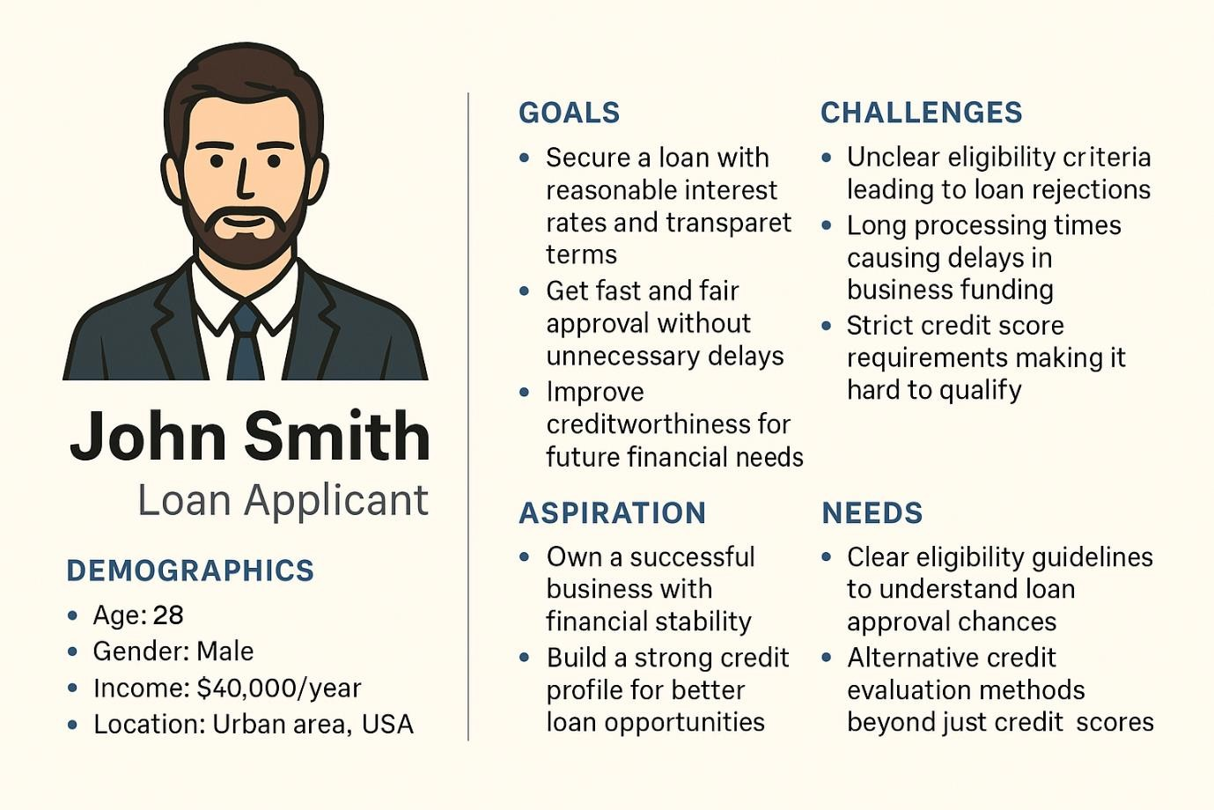

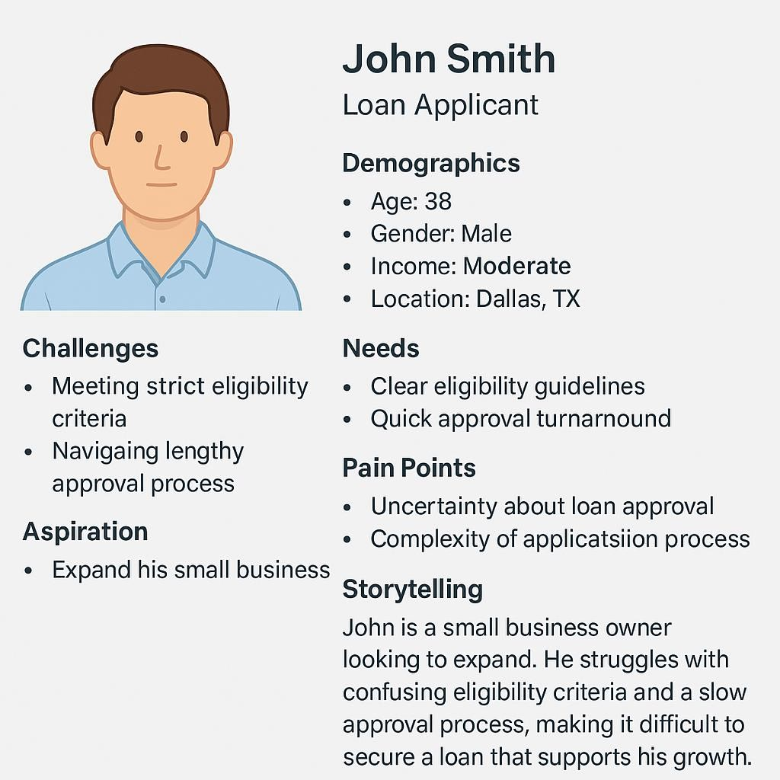

- Look for Common Themes, Behaviors, Needs, and Pain Points among the Users
Analyse the data from your affinity diagram to uncover recurring patterns among your users, helping you better understand their expectations and challenges.
Common Themes: Identify broad ideas or issues that repeatedly appear across different groups in your affinity diagram.

  - Users seek faster and more transparent loan approvals.

  - Many struggle with strict credit score requirements.

  - There is a demand for fairer lending options with clear eligibility criteria.

Common Behaviors: Observe how users consistently act or respond in relation to the problem or product throughout their journey.
  - Users research multiple lenders before applying for a loan.

  - Many seek advice from peers or financial experts before making decisions.

  - If rejected, users look for alternative financing options or ways to improve credit scores.

Common Needs: Pinpoint essential requirements or desires that many users share, highlighting what they need for a better experience.

  - Clear and fair loan eligibility criteria to improve approval chances.

  - Lower interest rates and flexible repayment options for affordability.

  - Quick and easy application processes to reduce stress and delays.

Common Pain Points: Look for frustrations or obstacles that frequently hinder the user experience, which your project can address.

  - Unclear rejection reasons causing confusion and frustration.

  - Hidden fees and high interest rates making loans harder to manage.

  - Long approval times delaying urgent financial needs.

- Define Needs and Insights of Your Users

User Needs: Define the core requirements your users have in relation to the problem or product. These could be functional, emotional, or societal needs that your solution must address.

  - Faster and transparent loan approval to reduce uncertainty and delays.

  - Fairer eligibility assessment that considers more than just credit scores.

  - Clear and honest loan terms with no hidden fees or unexpected charges.

User Insights: Summarize the key understandings or observations you've uncovered about your users' behaviors, motivations, and pain points. These insights provide a deeper understanding of why users behave the way they do and what drives their decisions.

  - Many users feel frustrated by unclear rejection reasons and lack of transparency in loan decisions.

  - Strict credit score dependency often excludes potential borrowers who are financially capable.

  - Users rely on peer recommendations, reviews, and financial experts before choosing a lender.

  - ​

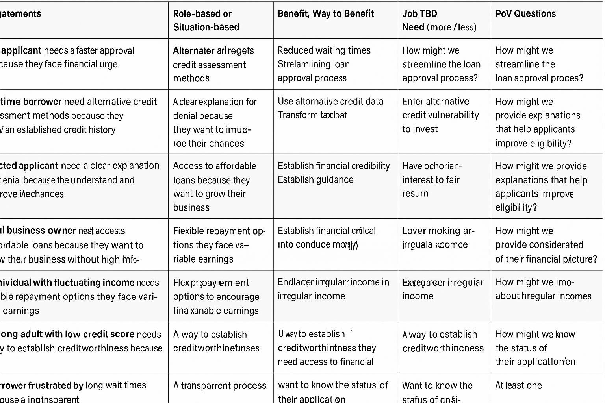

- Develop POV/How Might We (HMW) Questions to Transform Insights/Needs into Opportunities for Design
Turn your user needs and insights into actionable opportunities by framing them as "How Might We" (HMW) questions. These questions will spark creative problem-solving and guide your innovation process.
  - How Might We: Based on the needs and insights you've identified, create open- ended questions starting with "How might we...?" These questions should aim to solve user pain points, enhance the experience, or address specific needs.
Examples:
    - User Need: "Users need a quicker way to access customer support."
      - HMW Question: "How might we create a more efficient and accessible customer support system?"

    - Insight: "Users feel overwhelmed by too many options."
      - HMW Question: "How might we simplify decision-making for our users?"
    - • User Need: Users need a faster and more transparent loan approval process.
HMW Question: How might we streamline the loan application and approval process for quicker decisions?
    - • User Need: Borrowers struggle with unclear rejection reasons.
HMW Question: How might we provide clear, actionable feedback when a loan application is rejected?
    - • User Need: Fairer eligibility criteria beyond just credit scores.
HMW Question: How might we develop a more inclusive loan assessment system that considers alternative financial indicators?
    - • Insight: Users feel frustrated by hidden fees and unclear loan terms.
HMW Question: How might we make loan terms and conditions more transparent and easy to understand?
    - • Insight: Many applicants fear rejection and hesitate to apply.
HMW Question: How might we build confidence in applicants before they submit their loan applications?
    - • User Need: Borrowers require flexible repayment options.
HMW Question: How might we design repayment plans that adapt to borrowers’ financial situations?
    - • Insight: Long approval times push users toward high-interest alternative lenders. HMW Question: How might we reduce loan processing time without compromising accuracy?
    - • User Need: Users seek financial guidance to make informed borrowing decisions. HMW Question: How might we provide accessible financial education and tools for smarter loan decisions?
    - • Insight: Trust is a key factor in selecting a lender.
HMW Question: How might we enhance credibility and build trust between lenders and borrowers?

    - • User Need: Borrowers want an easier way to track their loan status. HMW Question: How might we create a real-time loan tracking system for applicants?

- Crafting a Balanced and Actionable Design Challenge
  - The Design Challenge Should Neither Be Too Narrow Nor Too Broad and It Should Be an Actionable Statement with a quantifiable goal. It should be a culmination of the POV questions developed.
  - Design Challenge: [Actionable Statement]

How might we develop a faster, fairer, and more transparent loan eligibility system? The system should provide clear feedback on loan decisions to reduce uncertainty.
It should incorporate alternative financial indicators beyond just credit scores. Flexible repayment options should be offered to improve borrower affordability. A real-time loan tracking feature should enhance user experience and trust.
The goal is to reduce approval time by at least 50% while maintaining accuracy.

- Validating the Problem Statement with Stakeholders for Alignment
Ensure your problem statement accurately represents the needs and concerns of your stakeholders and users. This involves gathering feedback from these groups to confirm that the problem is relevant and significant from their perspective. By validating early, you can refine the problem statement to better align with real-world challenges, ensuring your solution addresses the correct issues.
Validation Plan:

Stakeholder/User Feedback (Min. 10 Stakeholders/Experts):

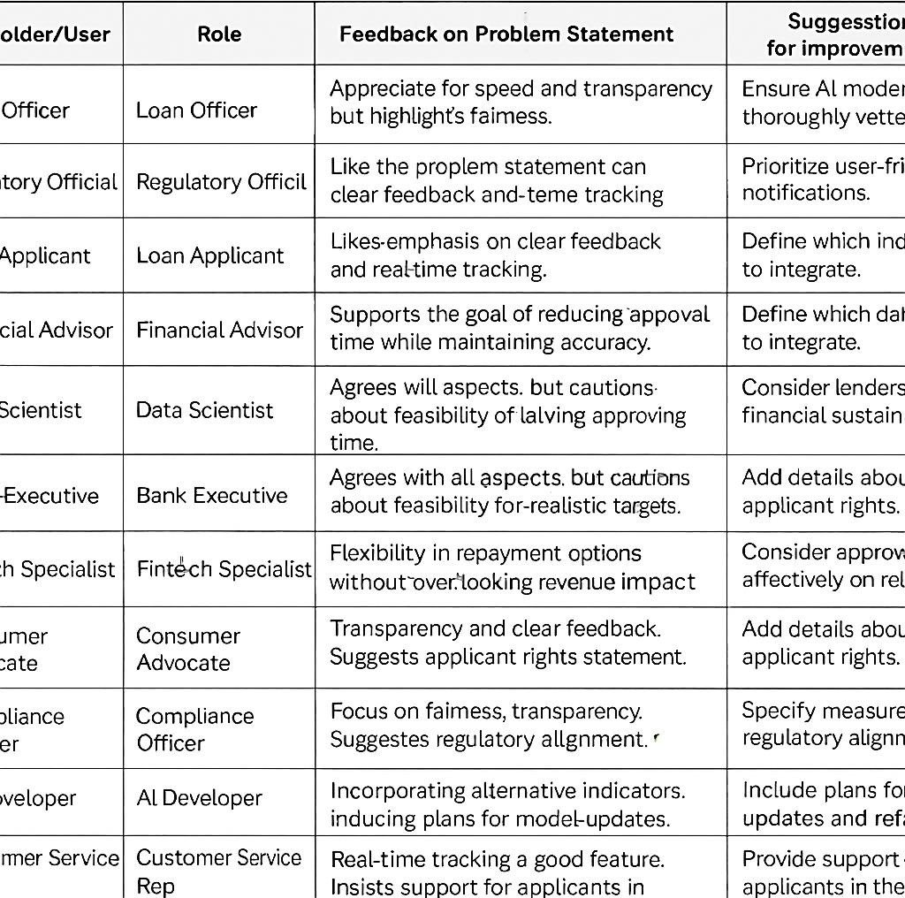

Solution Concept Form

- Problem Statement:

Loan applicants face complex eligibility criteria, long approval times, and lack of transparency, leading to frustration and financial uncertainty. Traditional systems rely
heavily on credit scores, which may not accurately reflect an applicant’s ability to repay. A more efficient, fair, and data-driven approach is needed to improve loan approval processes while maintaining financial security for lenders.

- Target Audience:

The target audience includes individuals and businesses seeking loans but facing challenges with traditional credit evaluation methods. This includes salaried professionals looking for personal or home loans, small business owners needing funding for growth, and freelancers or gig workers with irregular income streams. Students and young professionals applying for education or startup loans, as well as underbanked individuals with limited credit history, also form a key part of this audience. The solution aims to provide a fairer, more inclusive, and efficient loan approval process for these groups.

- Solution Overview:
The proposed solution is an AI-powered loan eligibility system that offers a faster, fairer, and more transparent approval process. Instead of relying solely on credit scores, it utilizes alternative financial indicators, such as income patterns, spending behavior, and transaction history, to assess creditworthiness. The system provides real-time loan status tracking, instant feedback on eligibility, and personalized loan options based on the applicant’s financial profile. By integrating automation and predictive analytics, the solution reduces approval times, minimizes bias, and enhances accessibility for underbanked individuals.

- Key Features

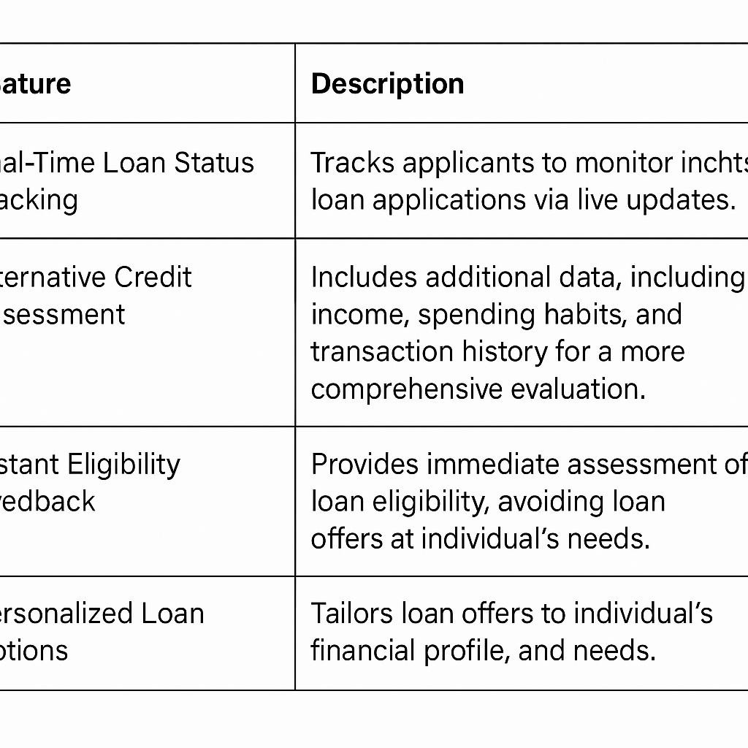

- Benefits:

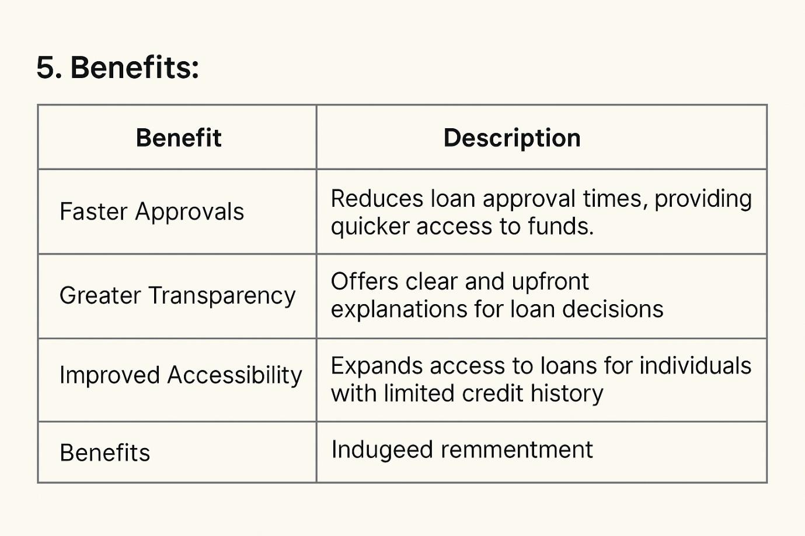

.6. Unique Value Proposition (UVP):

Our AI-driven loan eligibility system provides a faster, fairer, and more transparent approval process. It goes beyond traditional credit scores by analyzing alternative financial data for better accuracy. Applicants receive real-time loan status updates and personalized loan recommendations based on their financial behavior. Automation reduces processing time and operational costs, benefiting both lenders and borrowers. The system ensures greater financial inclusion by making loans accessible to underserved individuals.

- Key Metrics:

Metric | Description
Approval Time |  | Average time taken to approve or reject a loan application.
Approval Rate |  | Percentage of applications approved based on AI evaluation.
User Satisfaction Score |  |  |  | Feedback from users on transparency and ease of use.
Loan Default Rate |  |  | Percentage of loans that result in non-repayment.
- Feasibility Assessment:

echnical Feasibility | AI and automation technologies are mature and scalable for loan evaluation.
Financial Feasibility | Cost savings from automation justify initial investment in AI development.
Market Feasibility | High demand for faster, fairer loan approvals, especially for underserved borrowers.
Operational Feasibility |  | Integration with banking systems and credit bureaus is achievable.

  - Prototype Development – Build an initial version of the loan eligibility prediction system for testing.

  - Stakeholder Feedback – Gather insights from lenders, borrowers, and financial experts to refine the model.

  - Regulatory Compliance Check – Ensure adherence to financial and data protection regulations.

  - Pilot Testing – Run a small-scale test with real applicants to assess accuracy and efficiency.

  - ​

